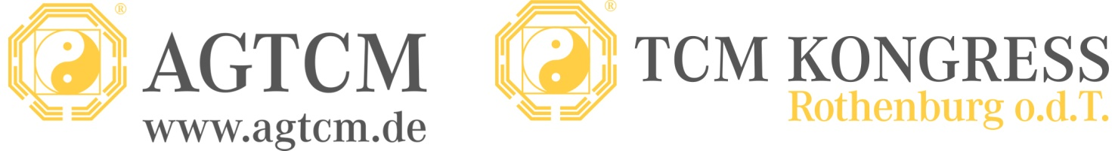

Press Release
The First Virtual Congress Was a Great Success; Virtualization Offers Many Advantages
Berlin, June 5, 2020 – For the first time, the renowned Rothenburg TCM Congress took place as an online-streaming program on May 19-23. The alternative solution to the physical Congress, which the coronavirus pandemic forced us to organize within the space of a few weeks, turned out to be a great success in retrospect, according to the organizers, the AGTCM board. Approximately 700 participants from 34 countries logged in for presentations and lectures from renowned speakers all over the world. Even the feeling of solidarity, an important aspect of the Congress, arose via online discussions and exchanges.
Dr. Martina Bögel-Witt, president of the AGTCM, is very satisfied. “The virtual congress absolutely fulfilled our expectations and enabled interesting content to be learned in an engaged way. Thanks to the professionalism and creativity of the presenters, many lectures were quite unusual,” she said.
Participants enjoyed morning Tai Chi with Lucas Wilkman, whose instruction took place during pleasant but windy weather, in a designated wetland region of France called the Camargue. The mosquitos were no deterrent. For many attendees, it was a new and positive experience to be able to visit more lectures without concern about the distance from classroom to classroom. In the absence of time pressures, participants were able to concentrate on learning without stress, in their own space. Additionally, the booked courses can be viewed for 30 days.
Interactivity is the key to success
Julia Stier, the leader responsible of the AGTCM for the Congress, worked around the clock with her team to prepare, and was rewarded with success. “The challenges to us, as the organizers, were of course quite different than usual. However, due to the implementation of good technical tools, our participants were able to quickly access their online courses and enjoy the advantages of an online presentation.”
According to Stier, interactive courses were especially popular. For example, Goro Hasewaga streamed from his practice in Japan while treating patients with his acupuncture method. Johannes Bernot engaged his viewers through content-related questions. Bernot, who is a board member of AGTCM, thinks that online streaming was a good solution for exceptional circumstances, but he said he still missed the personal interaction with attendees.
Solidarity and personal encounters
Many people were surprised by the ease with which solidarity was achieved, and - in the case of the opening ceremonies - even personalized encounters. The daily Tai Chi and Qi Gong courses also delighted participants. Reflecting on the Congress, Dr. Bögel-Witt stated, “This form of the Congress proved its worth. It conserves resources and saves time and money; travel expenses and hotel stays are avoided. At the same time, strolling through the wonderful old spa hotel, Wildbad, where the Congress takes place, and visiting with old and new friends, are experiences we missed.
“In the future, we would prefer to interact in real time again in Rothenburg,” she concluded. Still, the success of the event will lead the board of the AGTCM to consider if and how virtual methods can be integrated into futures congresses; for example, when an important lecturer cannot attend in person.

AGTCM is an interprofessional association for Chinese Medicine that advocates for the highest standards in the education and implementation of Traditional Chinese Medicine, including consideration of its modern aspects. Founded in 1954, most of its 1,700 current members are holistic practitioners and medical doctors who practice TCM. Members also include specialized physical therapists, midwives, and Sinologists. AGTCM is one of the most important professional associations for TCM in Germany, and in cooperation with five associated schools, upholds the highest educational standards for acupuncture, Chinese herbal therapy, Tuina, dietary therapy, and Qi Gong. (www.bildungsnetzwerk-tcm.de). Patients support AGTCM by searching for practitioners in their area, (www.agtcm.de/patienten/therapeuten-suche.php) and providing criteria for the quality of TCM treatments. AGTCM organizes the international TCM Congress in Rothenburg (o.d.T.) every year, which has evolved into the largest and most renowned TCM congress in the western world. AGTCM is a founding member of the European TCM Association (ETCMA) (www.etcma.org), a cooperative undertaking of 31 European countries.

Press Contact:
AGTCM
Juliane Papendorf
Telephone: +49 (0)176-10 30 51 87
E-mail: papendorf@agtcm.de
Website: www.agtcm.de

